Sports and Activity Leader

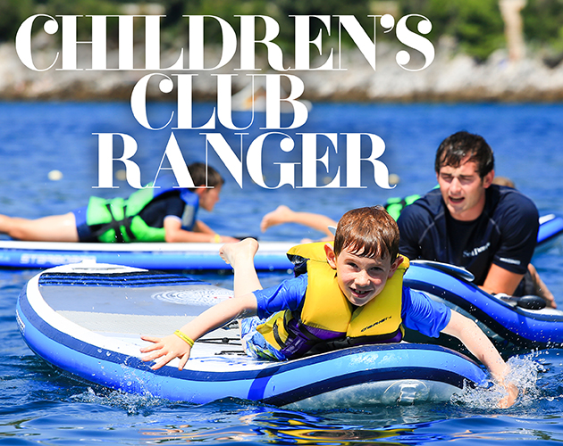

Do you have a passion for sports and the outdoors?

Love working with children and young people?

Fancy a change of scenery to some of the most beautiful locations in the world?

This might be the job for you!!

You will be part of the Children’s Club Team delivering a variety of sports focused activities on and off site! Whether a game of basketball or water polo challenge in the pool, our Activity Leaders are enthusiastic and motivated, providing a fun and varied activity programme! In your spare time you will be exploring hidden beaches, seeking out unspoilt villages and enjoying the delicacies and culture!

Main Responsibilities

- Ensure that guests and their children benefit from the highest level of childcare.
- Plan a variety of age appropriate and group size outdoor activities each week.
- Provide a service an attitude where ‘nothing is too much trouble’!

Essential Requirements

- Experience working with children aged 5-13 in a sports coaching/activity environment
- Sports Coaching or Activity leadership qualifications
- Ability to work in a team
- Knowledge of safety procedures
- Full, clean, driving license

Expectations

- Passion for working with children
- Self-motivated, safety conscious
- Passionate
- Team player
- Outgoing nature
- Professional demeanor
- Strong swimmer
- Creativity
- Positive attitude

Benefits

- Gain amazing experiences overseas
- Save your salary (accommodation costs met)
- Take your first career steps in the travel and tourism industry
- Form a worldwide network of lifelong friends

